Synopsis

Traffic Accident Severity Prediction

Problem Id: 20

Student Name: Priyani Singh, Suditi Verma
University Roll number: 2028806, 2028868
Section: P

- Problem Description:
- Traffic accidents are a major concern worldwide, leading to injuries, fatalities, and economic losses. Predicting the severity of accidents in advance can help authorities take preventive measures and improve road safety.
- This project aims to develop a machine learning-based system that predicts the severity of traffic accidents using factors such as speed, weather conditions, road condition, and vehicle type.
- The system processes raw data through preprocessing steps where missing values and irrelevant records are removed to ensure data quality. Feature selection techniques are applied to retain only the most impactful features, such as speed and weather conditions, improving model performance and efficiency.
- Two classification algorithms are used — Logistic Regression and Support Vector Machine (SVM) with three kernel types:
- Linear Kernel for simple linear separation
- Polynomial Kernel for non-linear curved boundaries
- RBF Kernel for complex patterns
- The models are trained on labelled accident data to classify severity levels (e.g., low, medium, high).
- Model performance is evaluated using confusion matrix and recall score to measure how effectively severe accidents are identified.
- The goal of this project is to identify the best-performing model for predicting accident severity, which can assist in traffic management and accident prevention.

- Steps of Implementation:
1. Data Collection
The dataset used in this project is taken from Kaggle. It contains information related to traffic accidents, including factors such as weather conditions, road conditions, vehicle type, and driver behavior. These features help in analyzing patterns and predicting the severity of accidents.
Dataset Link: https://www.kaggle.com/datasets/denkuznetz/traffic-accident-prediction/data
This dataset contains data aimed at predicting the severity of traffic accidents based on a variety of factors, including weather conditions, road types, traffic density, driver behavior, and more. It includes features such as weather, road conditions, time of day, vehicle types, driver age, and experience, providing a comprehensive view of the variables that contribute to traffic accidents.

2. Data Preprocessing
- Remove missing values and duplicate records
- Handle categorical variables using encoding techniques
- Normalize/standardize numerical features (speed, etc.)
- Remove irrelevant or noisy data
3. Feature Selection
Weather: The impact of weather conditions on the likelihood of accidents.
- Clear: No adverse weather conditions.
- Rainy: Rainy conditions increase the chance of accidents.
- Foggy: Foggy conditions reduce visibility, increasing accident chances.
- Snowy: Snow can cause slippery roads and higher accident probability.
- Stormy: Stormy weather can create hazardous driving conditions.
Road_Type: The type of road, influencing the probability of accidents.
- Highway: High-speed roads with higher chances of severe accidents.
- City Road: Roads within city limits, typically with more traffic and lower speeds.
- Rural Road: Roads outside urban areas, often with fewer vehicles and lower speeds.
- Mountain Road: Roads with curves and elevation changes, increasing accident risk.
Time_of_Day: The time of day when the accident occurs.
- Morning: The period between sunrise and noon.
- Afternoon: The period between noon and evening.
- Evening: The period just before sunset.
- Night: The nighttime, often associated with reduced visibility and higher risk.
Traffic_Density: The level of traffic on the road.
- 0: Low density (few vehicles).
- 1: Moderate density.
- 2: High density (many vehicles).
Speed_Limit: The maximum allowed speed on the road.
Number_of_Vehicles: The number of vehicles involved in the accident, ranging from 1 to 5.
Driver_Alcohol: Whether the driver consumed alcohol.
- 0: No alcohol consumption.
- 1: Alcohol consumption (which increases the likelihood of an accident).
Accident_Severity: The severity of the accident.
- Low: Minor accident.
- Moderate: Moderate accident with some damage or injuries.
- High: Severe accident with significant damage or injuries.
Road_Condition: The condition of the road surface.
- Dry: Dry roads with minimal risk.
- Wet: Wet roads due to rain, increasing the risk of accidents.
- Icy: Ice on the road, significantly increasing the risk of accidents.
- Under Construction: Roads under construction, which may have obstacles or poor road quality.
Vehicle_Type: The type of vehicle involved in the accident.
- Car: A regular passenger car.
- Truck: A large vehicle used for transporting goods.
- Motorcycle: A two-wheeled motor vehicle.
- Bus: A large vehicle used for public transportation.
Driver_Age: The age of the driver. Values range from 18 to 70 years old.
Driver_Experience: The years of experience the driver has. Values range from 0 to 50 years of experience.
Road_Light_Condition: The lighting conditions on the road.
- Daylight: Daytime, when visibility is typically good.
- Artificial Light: Road is illuminated with streetlights.
- No Light: Road is not illuminated, typically during the night in poorly lit areas.
4. Train-Test Split
- Split dataset into:
- 80% training data
- 20% testing data
- Use random_state = 42 for consistency
5. Model Training
- Train the following models:
- Logistic Regression
- SVM with Linear Kernel
- SVM with Polynomial Kernel
- SVM with RBF Kernel
6. Model Evaluation
- Evaluate models using:
- Confusion Matrix
- Recall Score
7. Final Model Selection
- Compare models based on recall and confusion matrix
- Select model with best performance in detecting severe accidents

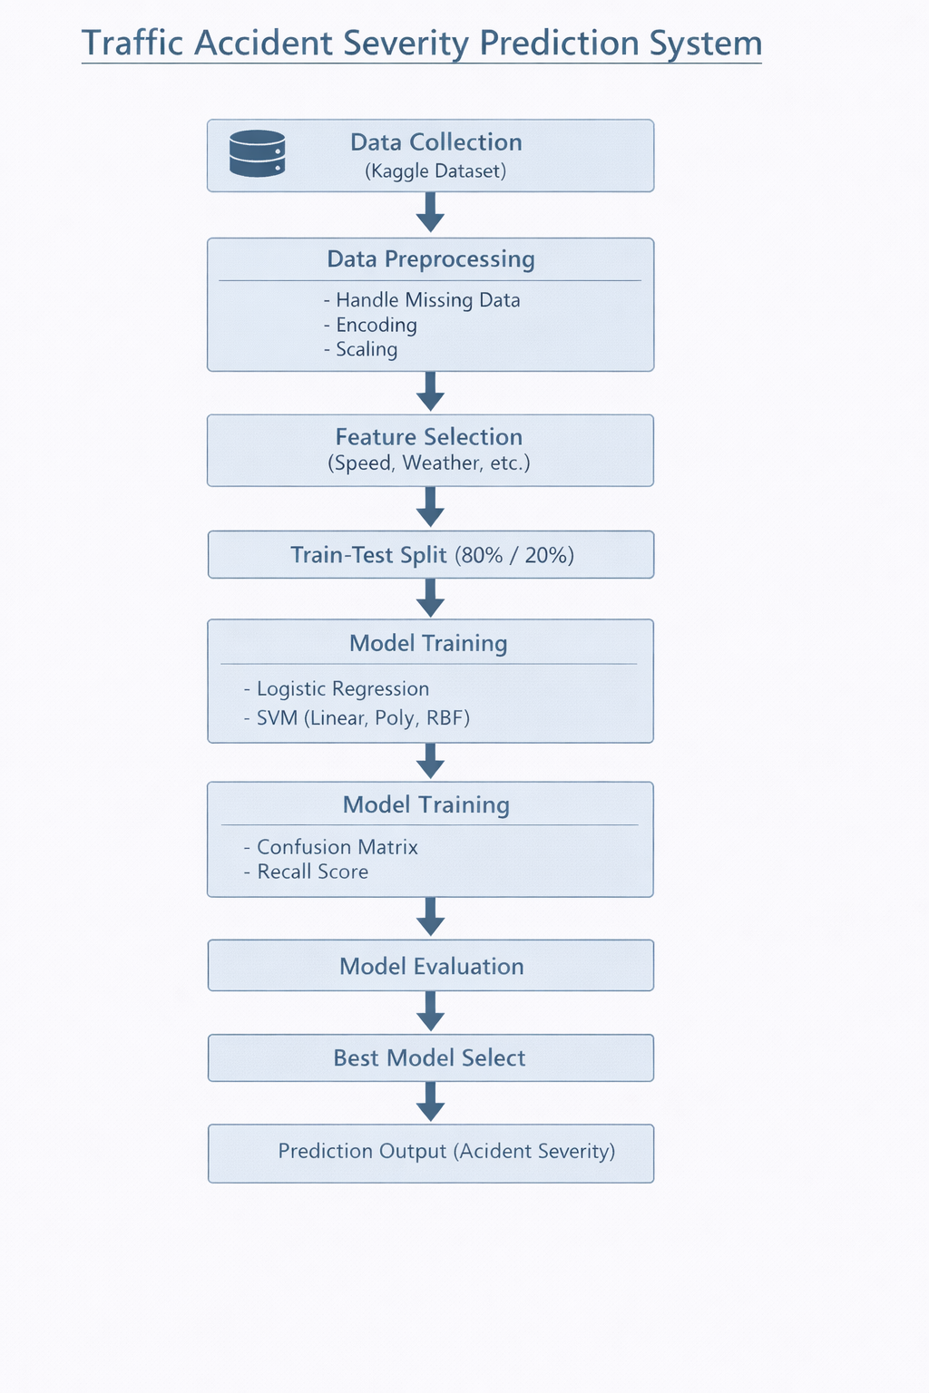

- Expected Modules/ Libraries to be used :
- pandas – Data loading and preprocessing
- numpy – Numerical computations
- scikit-learn – preprocessing – Scaling and encoding
- scikit-learn – train_test_split – Dataset splitting
- scikit-learn – LogisticRegression – Model training
- scikit-learn – SVC – SVM models with kernels
- scikit-learn – confusion_matrix – Model evaluation
- scikit-learn – recall_score – Performance metric
- matplotlib – Visualization
- seaborn – Heatmap for confusion matrix

- Expected Evaluation metrics and Plots to be used:
Evaluation Metrics
- Recall Score: This measures how many actual severe accidents are correctly identified by the model. It is important because missing a severe accident can be dangerous, so we focus more on recall than just accuracy.
- Confusion Matrix: It is a table that shows how well the model is performing by displaying correct and incorrect predictions in terms of TP, TN, FP, and FN. It helps us understand the types of errors the model is making.
- True Positive (TP): These are the severe accidents that are correctly predicted as severe. A higher TP means the model is doing well in identifying critical cases.
- True Negative (TN): These are the non-severe accidents that are correctly predicted as non-severe. A higher TN shows the model is also accurate for normal cases.
- False Positive (FP): These are non-severe accidents that are wrongly predicted as severe. This may lead to unnecessary alerts or actions.
- False Negative (FN): These are severe accidents that are wrongly predicted as non-severe. This is the most serious error because it means dangerous situations are missed.
Visualization Plots
- Bar Chart — Accident Severity Distribution This chart shows how many accidents fall into each category (low, medium, high). It helps in understanding whether the dataset is balanced or not.
- Confusion Matrix Heatmap — This is a visual representation of the confusion matrix using colors. It makes it easier to quickly compare how well each model is performing.
- Bar Chart — Model Recall Comparison This chart compares the recall values of all models side by side, helping us easily identify which model is best at detecting severe accidents.

- Required topics from the subject:
• Supervised Learning— In this project, we use supervised learning where the model is trained on already labeled accident data and learns to predict the severity of new accidents.
• Classification— The problem is a classification task where each accident is classified into categories like low, medium, or high severity.
• Data Preprocessing— This step includes cleaning the dataset by handling missing values, converting categorical data into numerical form, and scaling features like speed.
• Feature Selection— Only the most important features such as speed, weather conditions, and road condition are selected to improve the model’s efficiency and accuracy.
• Train Test Split— The dataset is divided into training and testing parts so that we can check how well the model performs on new, unseen data.
• Logistic Regression— It is a basic and widely used classification algorithm that serves as a baseline model in this project.
• Support Vector Machine (SVM) — This is a powerful algorithm used for classification, and it works well for both simple and complex data patterns.
• Kernel Functions— Different kernels like Linear, Polynomial, and RBF are used in SVM to handle different types of relationships in the data.
• Model Evaluation— We will prioritize Recall as our primary metric to minimize False Negatives (severe accidents predicted as non-severe). Additionally, the Confusion Matrix and F1-Score will be used to ensure a robust trade-off between sensitivity and precision.
• Confusion Matrix— It helps in analyzing the performance of the model in detail by showing correct and incorrect predictions.
• Data Visualization— Graphs and plots are used to better understand the dataset and compare the performance of different models.

- Platform Required:
Jupyter Notebook

- Books and Link Sources:
https://scikit-learn.org/stable/
https://www.geeksforgeeks.org/machine-learning/
https://www.geeksforgeeks.org/support-vector-machine-algorithm/
An Introduction to Artificial Intelligence and Machine Learning – S. Chand

